Ankith S Vaidya

Ethical Hacking and Cyber Security Assignment Day 8

**To create a user named bob in kali**

* Go to terminal as root user
* useradd -m bob
* by using passwd give passwd
* enter new password
* confirm the new password
* you can use sudo apt – get update and then put the password for bob

**Enabling ssh service on kali**

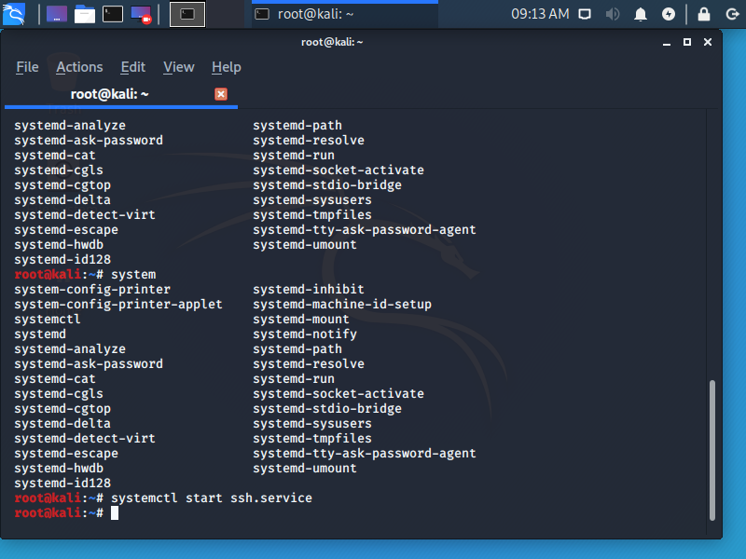

**Gitbash thing**

